PowerShell Installation and Usage

You can use Windows PowerShell. You could also use PowerShell 7, which is a newer version for Windows, Mac, and Linux.

I suggest you use Windows Terminal.

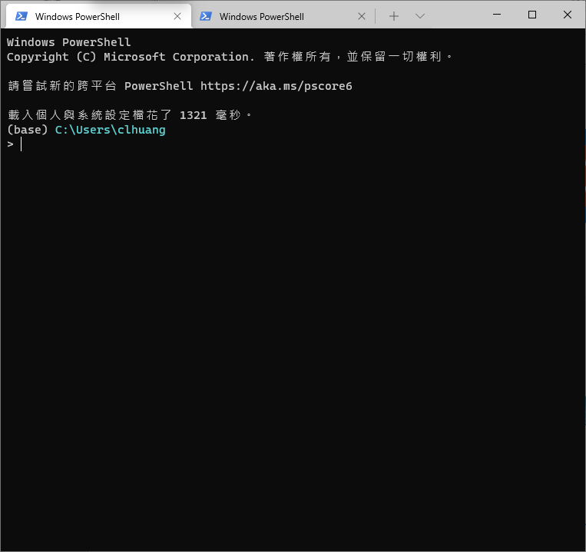

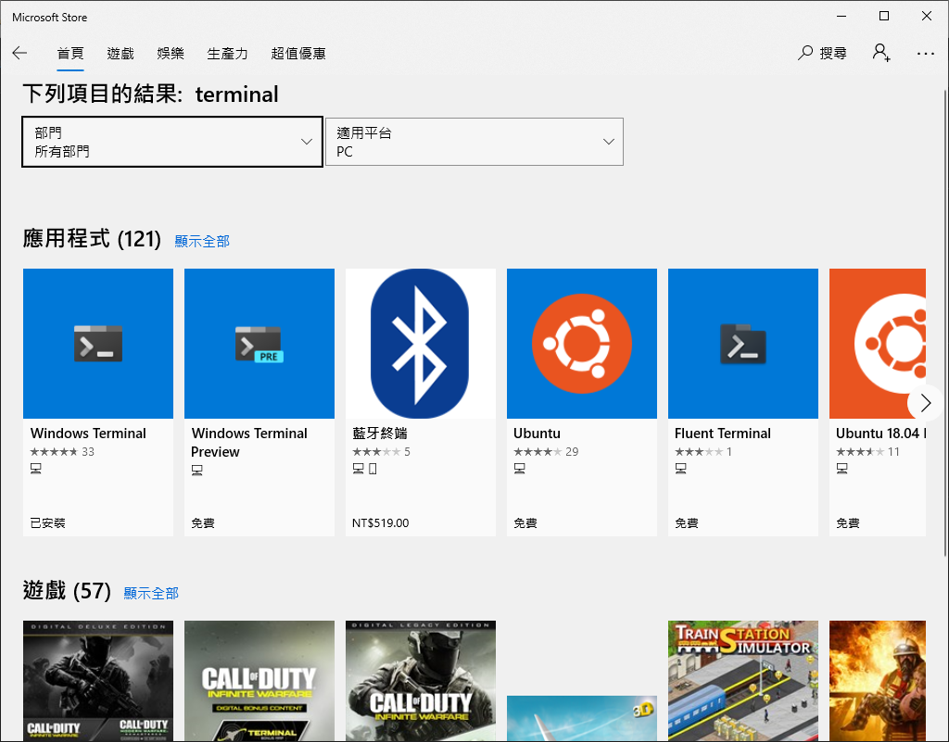

Step1: Enable to use conda command in Powershell

讓命令列可以與conda虛擬環境整合。

$>conda init powershell

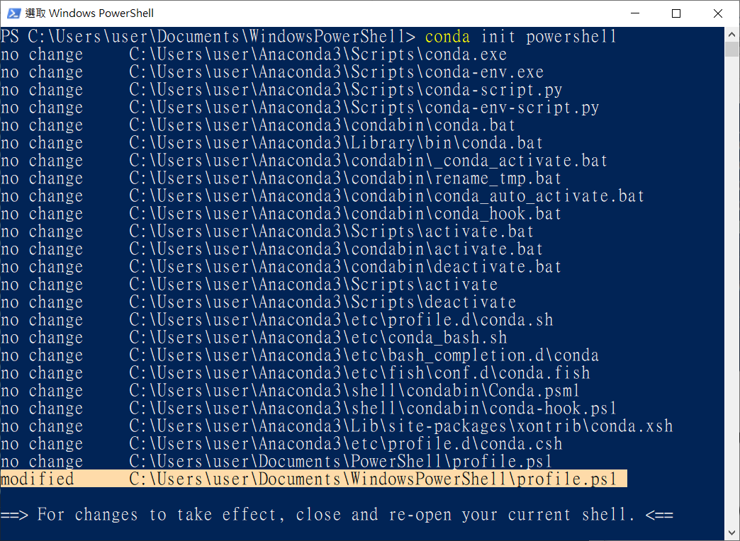

Step 2: Modify profile.ps1

注意: 有沒有看到profile.ps1是位在哪裡?

The profile of Windows PowerShell is located in your Documents directory:

“C:/Users/user/Documents/WindowsPowerShell/profile.ps1”

“user” is the user name in my PC.

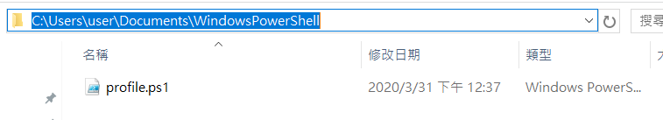

Note:

If you install PowerShell 7, the profile of PowerShell 7 is located in your Documents directory:

“C:/Users/user/Documents/PowerShell/profile.ps1”

The following commands will be automatically inserted into the profile.

#region conda initialize

# !! Contents within this block are managed by 'conda init' !!

(& "C:\Users\user\Anaconda3\Scripts\conda.exe" "shell.powershell" "hook") | Out-String | Invoke-Expression

#endregion

Step 3: Shorten Path in PowerShell

The profile of Windows PowerShell is in your documents directory. The full path is as follows:

“C:/Users/user_name/Documents/WindowsPowerShell/Microsoft.PowerShell_profile.ps1”

If the file doesn't exist, then create it. Then place the following function in the profile script:

在profile.ps1檔案內容的最前面，加入以下這段文字:

function prompt {

Write-Host $ExecutionContext.SessionState.Path.CurrentLocation -ForegroundColor Cyan

"$('>' * ($nestedPromptLevel + 1)) "

}

現在檔案內容看起來是這樣:

Now in the profile you will have the following scripts:

function prompt {

Write-Host $ExecutionContext.SessionState.Path.CurrentLocation -ForegroundColor Cyan

"$('>' * ($nestedPromptLevel + 1)) "

}

#region conda initialize

# !! Contents within this block are managed by 'conda init' !!

(& "C:\Users\user\Anaconda3\Scripts\conda.exe" "shell.powershell" "hook") | Out-String | Invoke-Expression

#endregion

Step 4: Set execution policy to “RemoteSigned”

Do you get the following message when opening PowerShell?

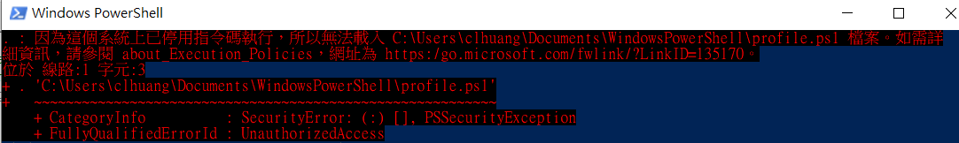

以系統管理員身分重新開一個新的Terminal視窗，執行以下命令:

Update the PowerShell execution policy on the system to allow the script to run. In the PowerShell window, enter set-executionpolicy RemoteSigned. The system will prompt to confirm the change. Enter the letter Y or press the enter key to change the execution policy setting.

$>Set-ExecutionPolicy RemoteSigned

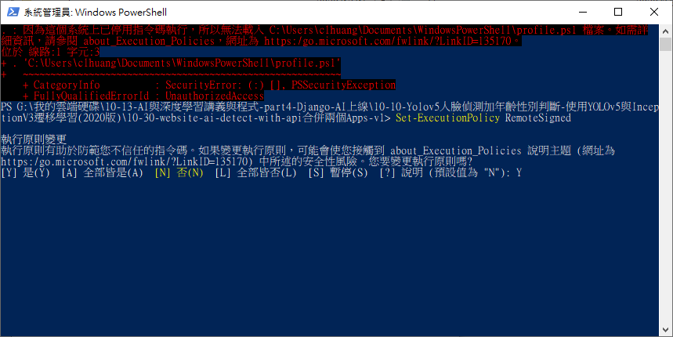

以系統管理員身分執行

輸入:“Y”

**「執行原則」**有下列 4 種：

Restricted ：關閉腳本檔的執行功能，這是預設的設定值。

AllSigned ：只允許執行受信任發行者簽署過的腳本檔。

RemoteSigned ：在本機電腦所撰寫的腳本檔，不需要簽署就可執行；但是從網際網路（例如：email、MSN Messenger）下載的腳本檔就必須經過受信任發行者的簽署才能執行。

Unrestricted ：任何腳本檔皆可被執行，但是於執行網際網路下載的腳本檔時，會先出現警告的提示視窗。

我們可以利用 Get-ExecutionPolicy 來確認系統目前的指令檔執行限制為何：

Check up the PowerShell execution policy on the system:

$>Get-ExecutionPolicy

~~PowerShell 7 download and installation~~

